Task 1: Develop a c program using fork() that creates a parent and child process. Display the process ID (PID), Parent process ID (PPID), and process states at different stages of execution
Step 1
Create file
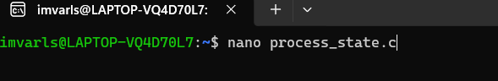

Step 2
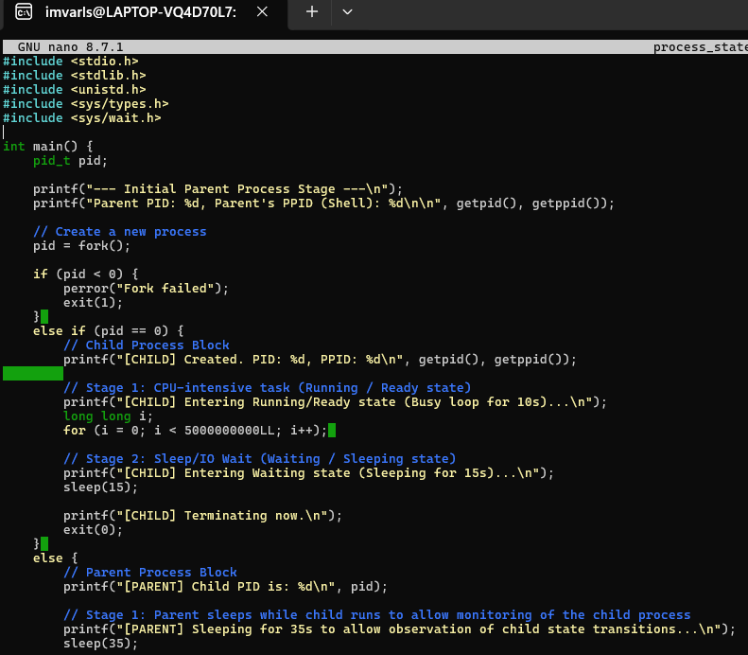

Step 3
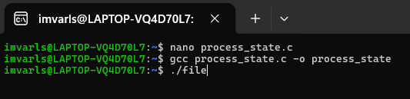

Output

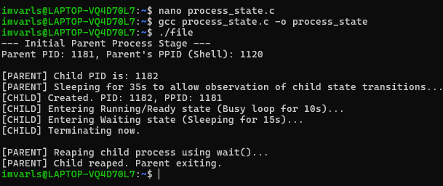

Task 2 Design an experiment to observe process state transitions (Ready, Running, Waiting, terminates) using Linux monitoring tools such as ps, top, and /proc. Document the observations.
Step 1 Create file
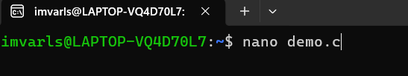

Step 2 Code

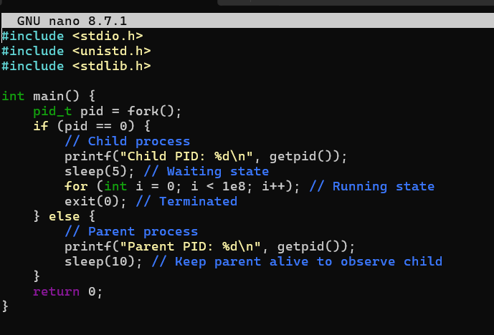

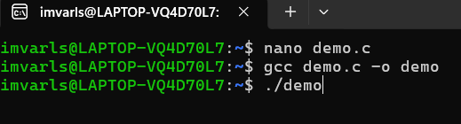

Outputs

